

**NEW ERA UNIVERSITY COLLEGE**

**Department of Computer Science & Information Technology**

**Diploma in E-Commerce &**

**Diploma in Web Development**

**TWEB223**

**Web Programming**

**Project Report: Hotel Booking System**

|  |  |
| --- | --- |
| **Student Name** | **Student Id** |
| Chen Gui Wen | 2050316-DEC |
| Chiew Chia Yu | 2050064-DWD |
| Leow Yong Wei | 2020053-DWD |
| Siew Tian Cheng | 2050319-DWD |
| Wong Jun Ann | 2020066-DWD |
| Yan Yong Kang | 2050263-DWD |

**Lecturer: Ms Wong Shi Wei**

**DATE OF SUBMISSION: to be written by lecturer**

Contents

Introduction 3

Functionality of module 4

Customer Interface 4

1. Homepage 4

2. Sign Up 4

3. Login 4

4. Payment 4

5. Customer Profile 4

Admin 5

1. Login 5

2. Booking List 5

3. User List 5

4. Room List 5

Contribution 6

Website Screen Shot 7

Admin Site 7

Home Page 7

User Information Page 7

Booking Page 8

Room Page 9

User Site 10

Login Page 10

Sign Up Page 10

Home Page 11

Profile Page 11

Booking Table from Home Page 12

Booking Page 12

Payment Gateway Page 13

Payment Success Page 13

Guest Site 14

Home Page 14

Booking Table from Home Page 14

# Introduction

1. What is the purpose of this system?

Hotel Booking System can be really helpful for hotel managers, employees as well as customers. It solves many problems for hotel by providing room booking services for travellers/customers and the employees. It is hotel reservation website.

2. Why did we create this website?

We created this website to allow users to have a simple and easy-to-operate system.

3. Who is the targeted audience for the system?

Our targeted audience is travellers whether are foreign or local.

4. What is the advantage of this system?

This system makes a convenient way for the users for making booking and the hotel for managing the bookings.

# Functionality of module

## Customer Interface

The visitors can book rooms by simply clicking on the book button which will then prompt the user to fill in user and booking details. So, if user provides correct inputs, then the booking will be successful. The user can search for rooms by typing the room type in the search bar. Also, the signed in user can see his/her room bookings by following the bookings link from the navigation bar. But the rooms page is only available to the admin user.

## 1. Homepage

➢ Homepage module is used for displaying latest updated information and product category that we sell.

➢ User is available to see the latest information in homepage.

## 2. Sign Up

➢ Sign up module enable user who first-time visit our website to register their own account for this system.

➢ After register, user will be directed to the login page.

## 3. Login

➢ Login module is used for the user access the system.

➢ After login, user can access to our website and able to checkout their order.

## 4. Payment

➢ Payment modules allow customer to use online payment method to checkout.

## 5. Customer Profile

➢ Users has authority to change own profile name, email address, and picture.

## Admin

The admin can add, edit and delete rooms but the default user can only add, edit and delete his/her bookings. Moreover, a visitor can make a new account on the hotel booking site by registering.

## 1. Login

➢ Login module is used for the admin access the system.

## 2. Booking List

➢ View user order details which is booking history, customer-info and booking product-details.

➢ Admins can view the customer booking information who ordered the product and the payment status.

## 3. User List

➢ To view the customer information.

## 4. Room List

➢ Able to view the current status of the product, able to edit, manage the product.

➢ Able to add new product.

# Contribution

The report was written by: Chen Gui Wen, Leow Yong Wei, Siew Tian Cheng, Wong Jun Ann.

**Website Contribution**

|  |  |  |  |  |
| --- | --- | --- | --- | --- |
| No. | Name | Role | | |
| Developer | Designer | Bug Tester |
| 1 | Wong Jun Ann (Leader) | ✔ | ✔ | ✔ |
| 2 | Leow Yong Wei | ✔ | ✔ |  |
| 3 | Chen Gui Wen | ✔ |  |  |
| 4 | Chiew Chia Yu |  | ✔ |  |
| 5 | Yan Yong Kang |  | ✔ | ✔ |
| 6 | Siew Tian Cheng | ✔ | ✔ |  |

# Website Screen Shot

## Admin Site

The main pages of the admin site are shown below:

### Home Page

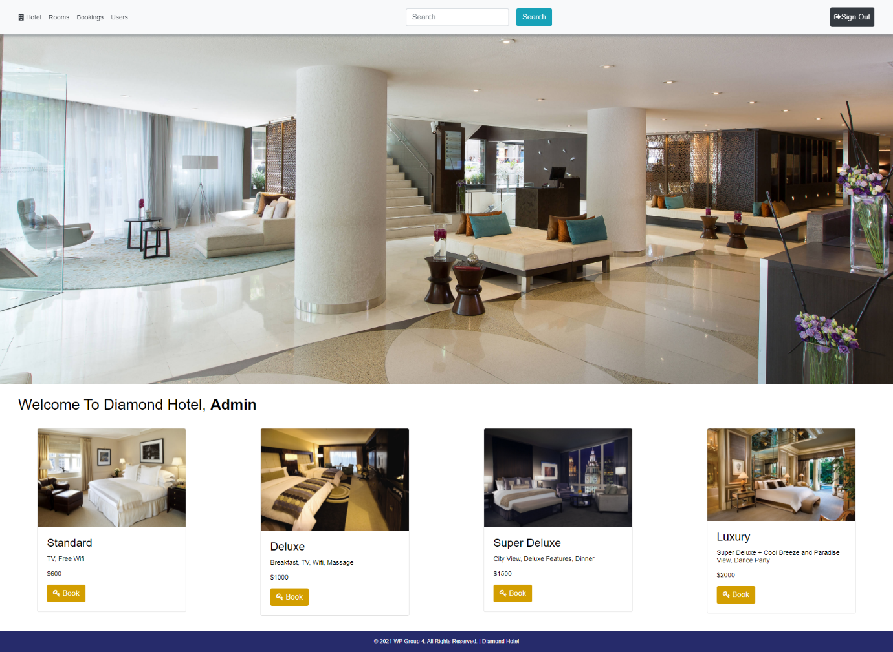

### User Information Page

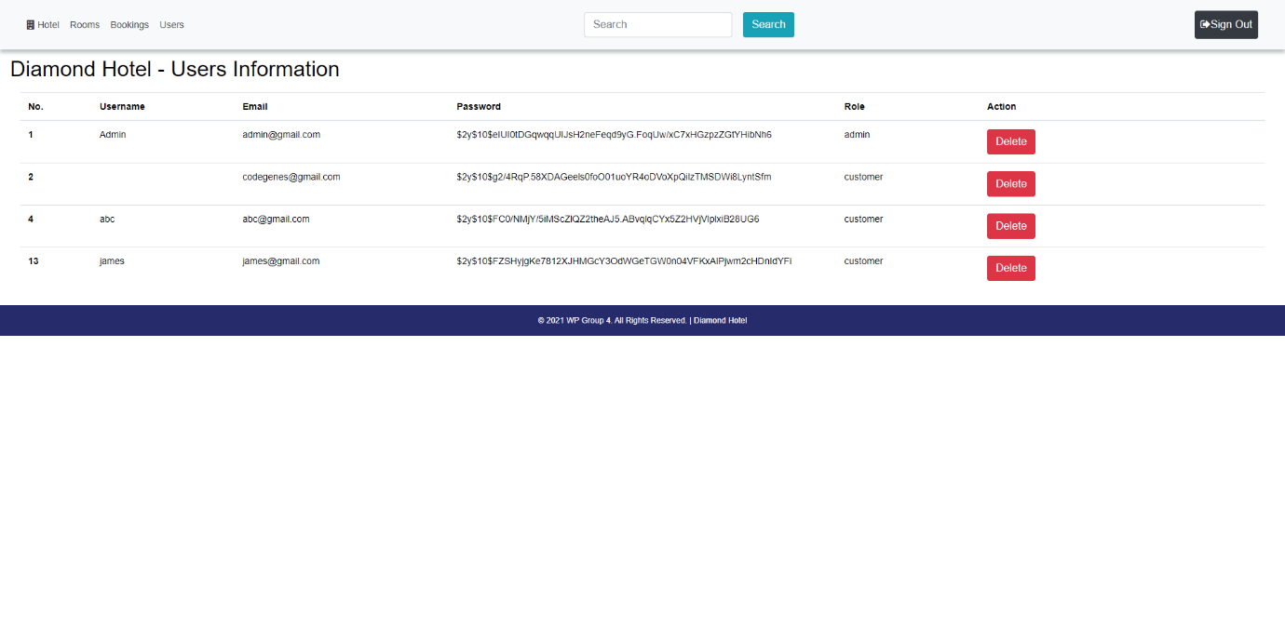

### Booking Page

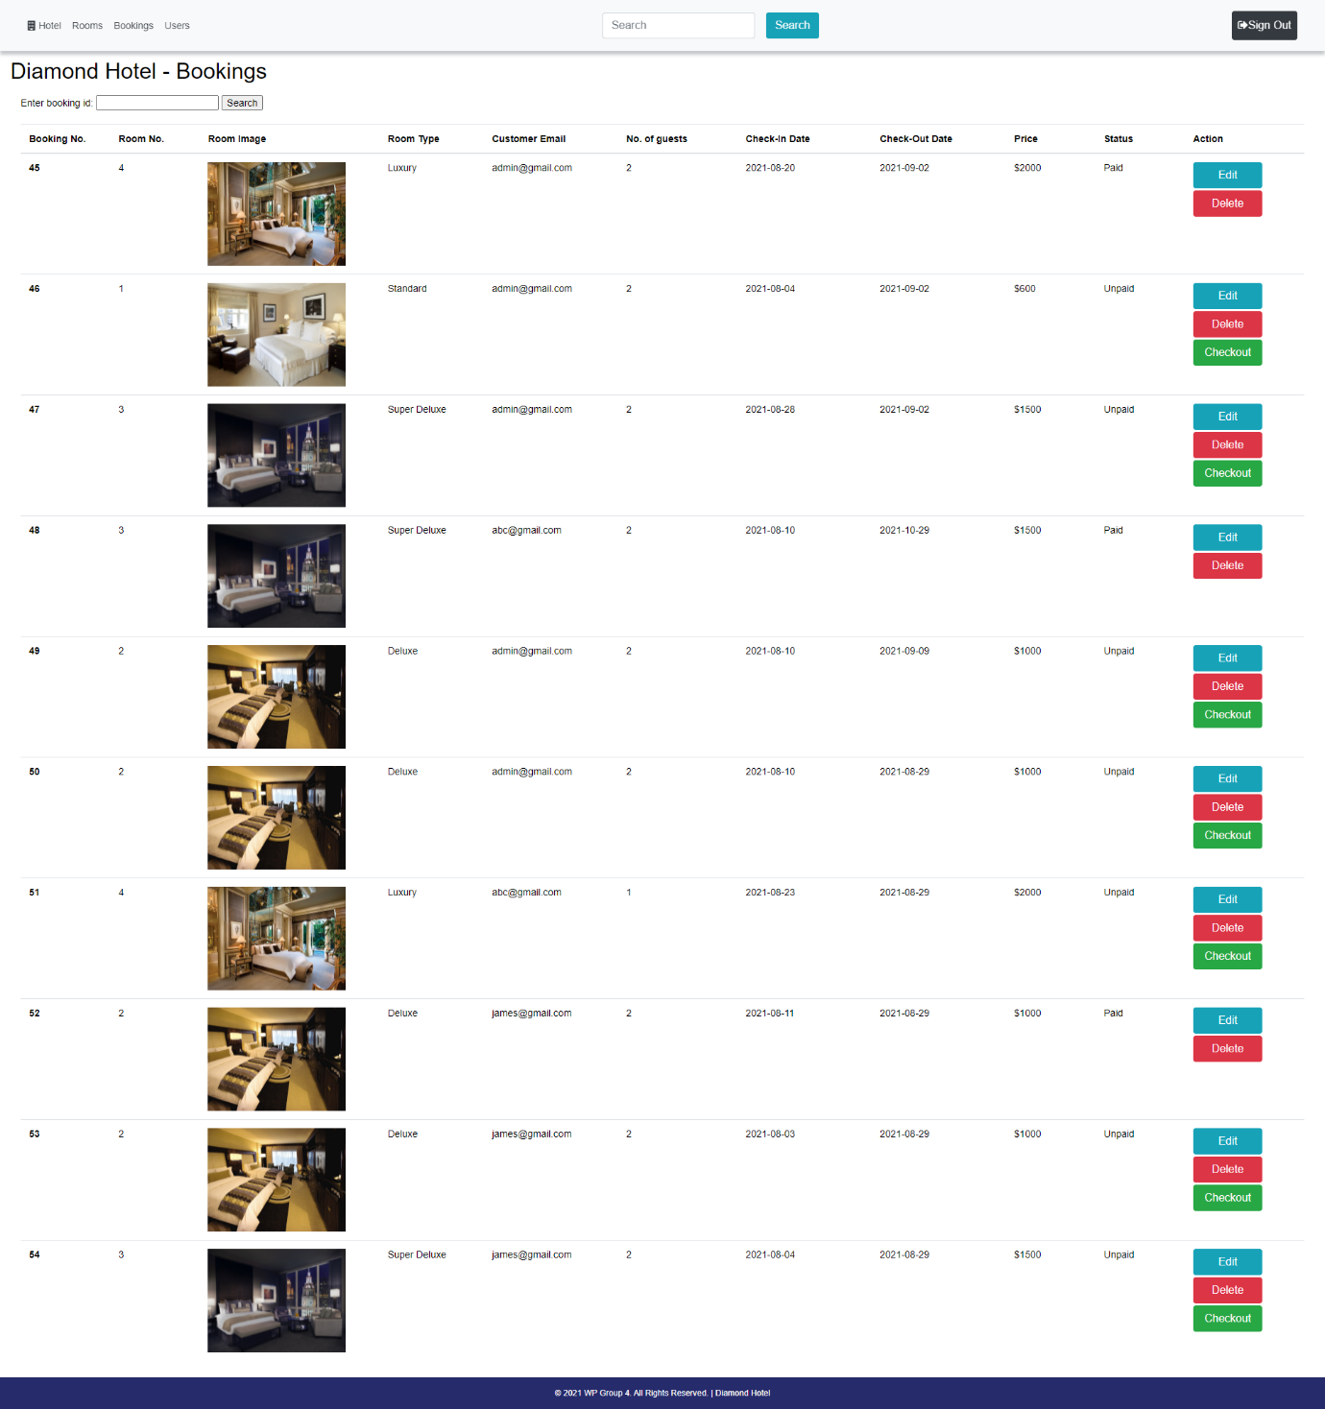

### Room Page

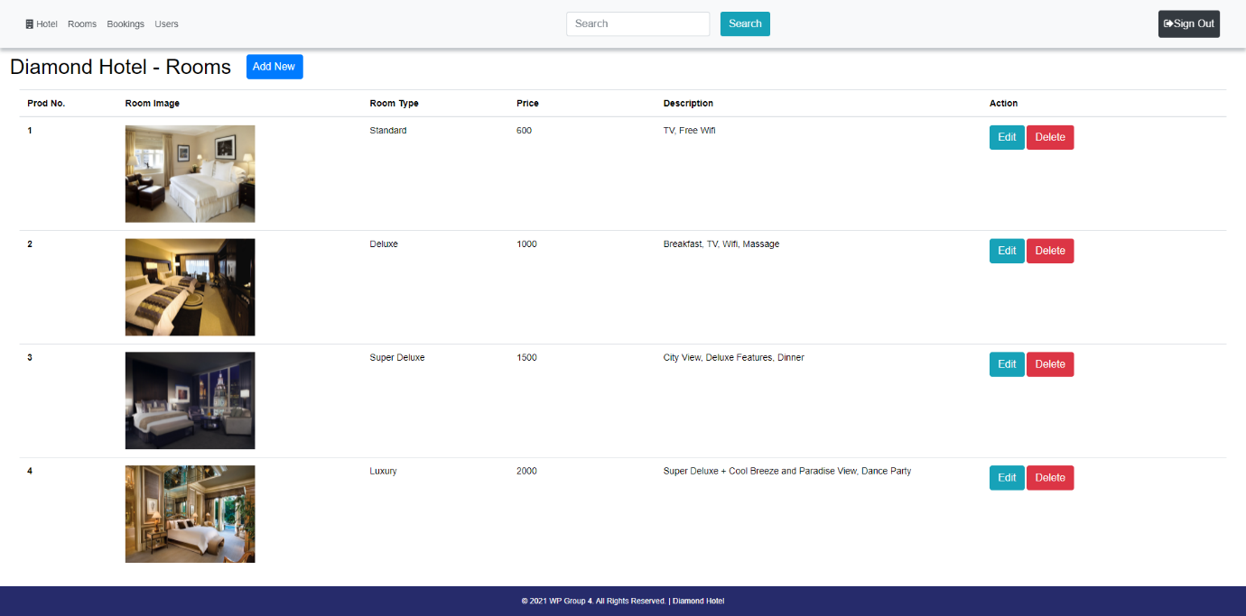

## User Site

The main pages of the user site are shown below:

### Login Page

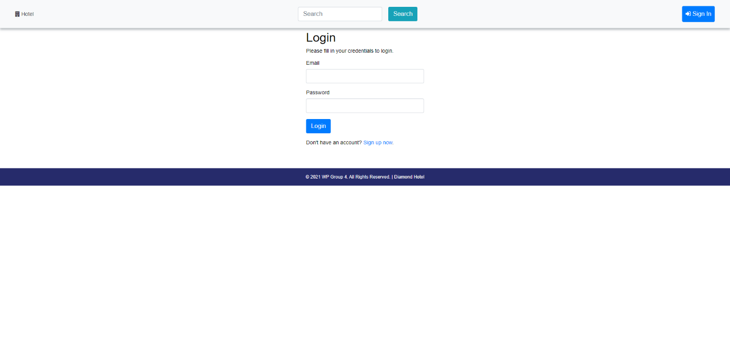

### Sign Up Page

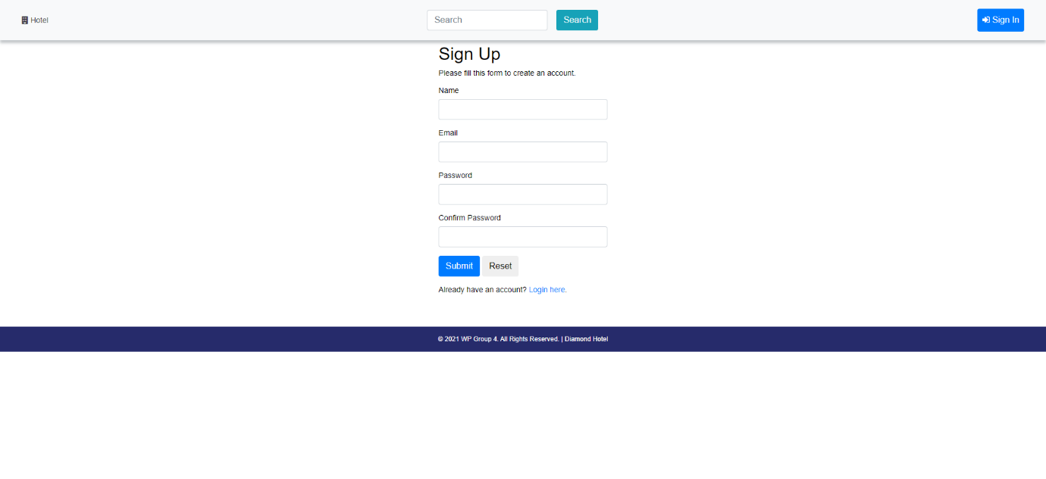

### Home Page

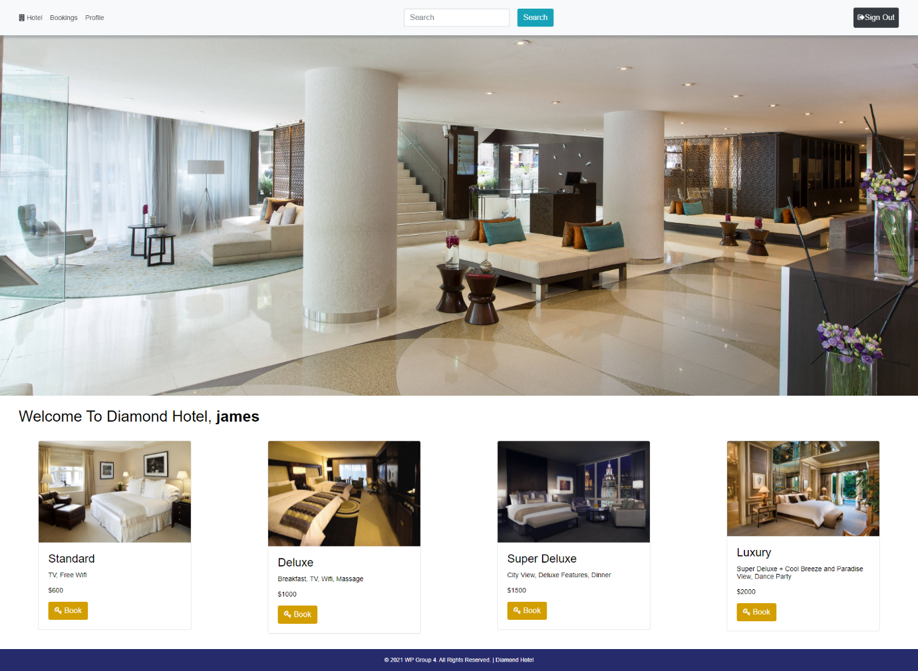

### Profile Page

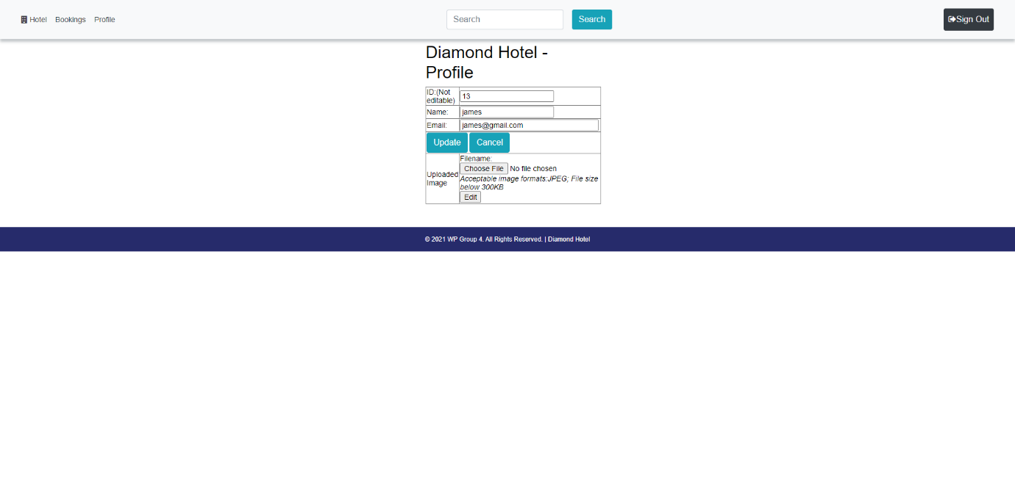

### Booking Table from Home Page

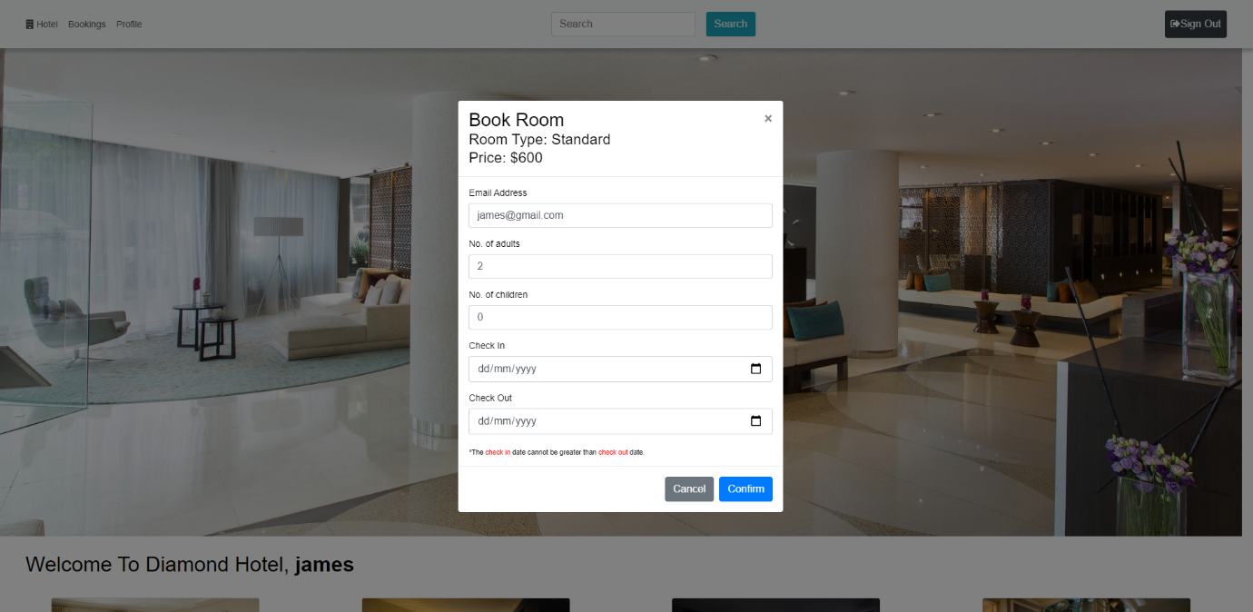

### Booking Page

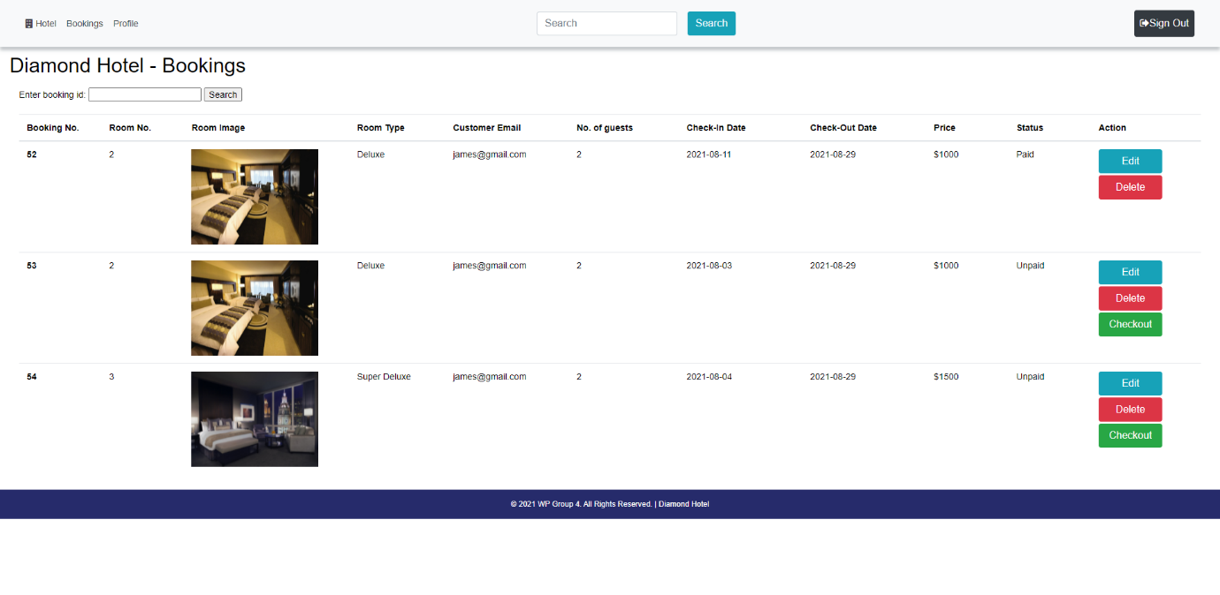

*The action button may change automatically. For example, a checkout button will be provided for user to pay the specific order, if the user hasn’t paid.*

### Payment Gateway Page

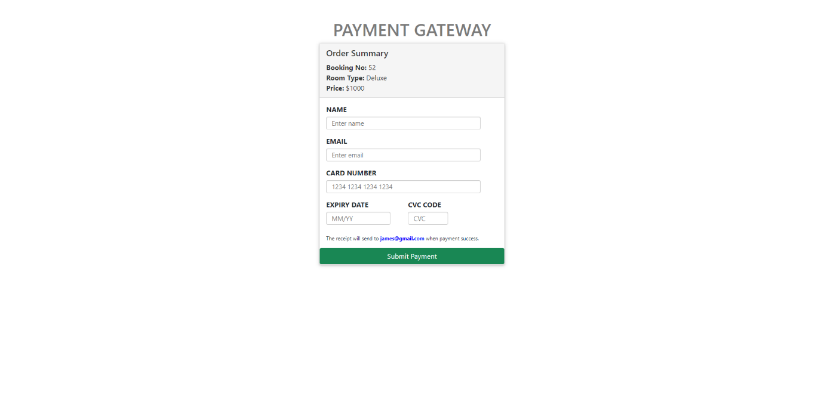

*If the customer clicks the checkout button from the booking page. It will navigate to the payment page. It shows a payment form and the detail of the product order summary. It will send the receipt to your email when your payment is successful.*

### Payment Success Page

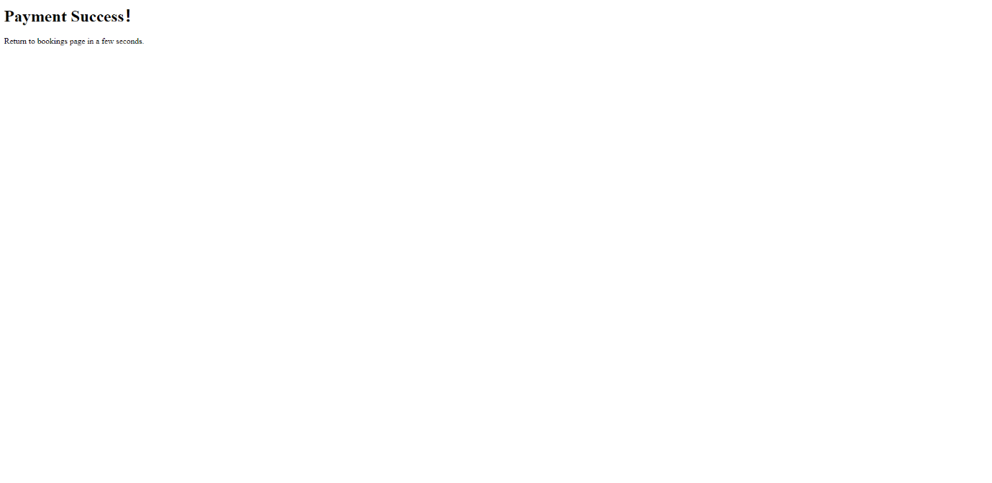

*It will navigate to the success page when your payment is successful, and redirect to the booking page in a few seconds.*

## Guest Site

The main pages of the guest site (visitor who haven't signup) are shown below:

### Home Page

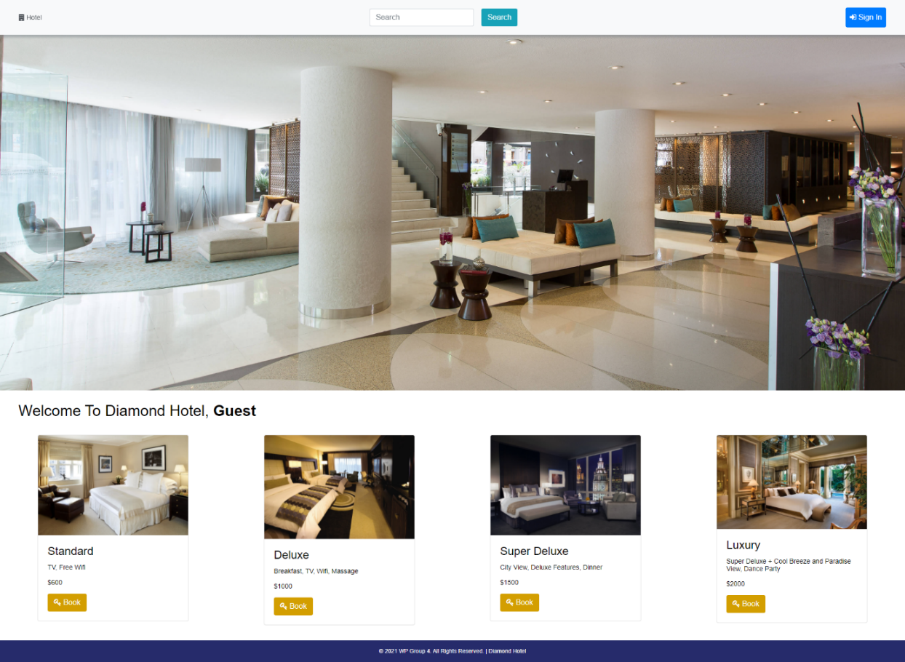

### Booking Table from Home Page

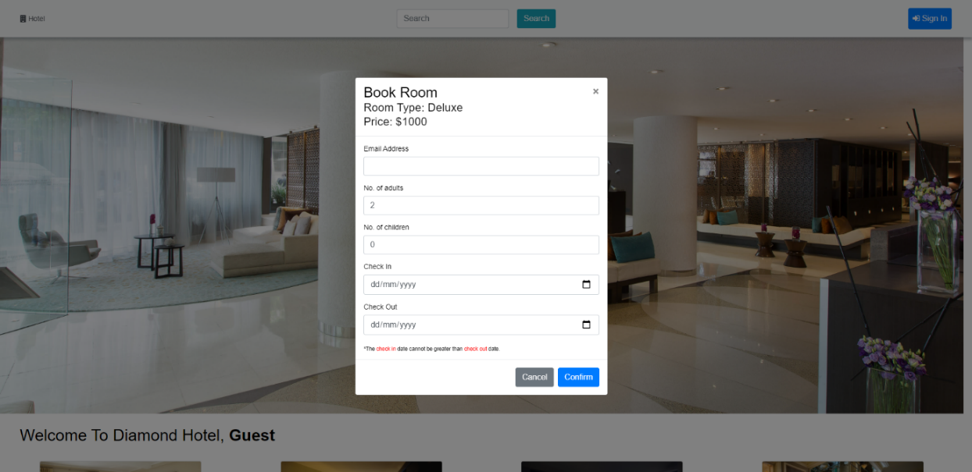

*For the guest who doesn't signup are unable to view their booking information after booking.*